**107上第­二次段考六年級口試題目**

1. **單字：**

a.請唸出老師指定的兩個單字

shout shower soil

point policy pain

forest flower follow

b.請唸出老師指定圖片的兩個單字

|  |  |  |
| --- | --- | --- |
|  |  |  |
|  |  |  |

**B.句型：老師抽一題，T:老師問, S:考生答**

1. T: What do you do after school?

S: ______________________. (請依實際情況回答完整的句子)

1. T: What does Amy do after school?

S: **She** ____________________________.

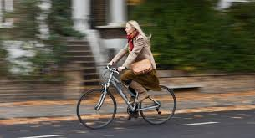

1. T: What time do you go to school?

S: _________________.(請依實際情況回答完整的句子)

1. T: What time does he go home?

5:30

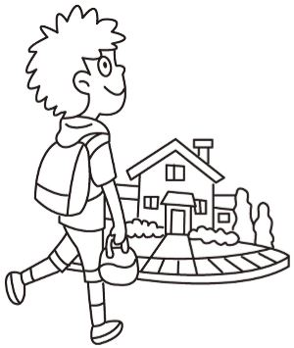

S: He ____________________________________.

**C.韻文：老師抽一首**

1. The mouse and the cow live in a nice big house.

2. Roy puts soybeans and coins in his toy.

3.The soybeans and the coins make a loud noice.

4.The cow likes to shout out loud in the shower.

**D. 課文：老師抽一課**