**107上第­二次段考五年級口試題目**

1. **單字：**

a.請唸出老師指定的兩個單字

king pink bank

short shop ship

chair church fish

b.請唸出老師指定圖片的兩個單字

(要注意單數或複數)

|  |  |  |
| --- | --- | --- |
|  |  |  |
|  |  |  |

**B.句型：(T:老師問, S:考生答)**

1. T: What’s wrong?

S: He ________________.

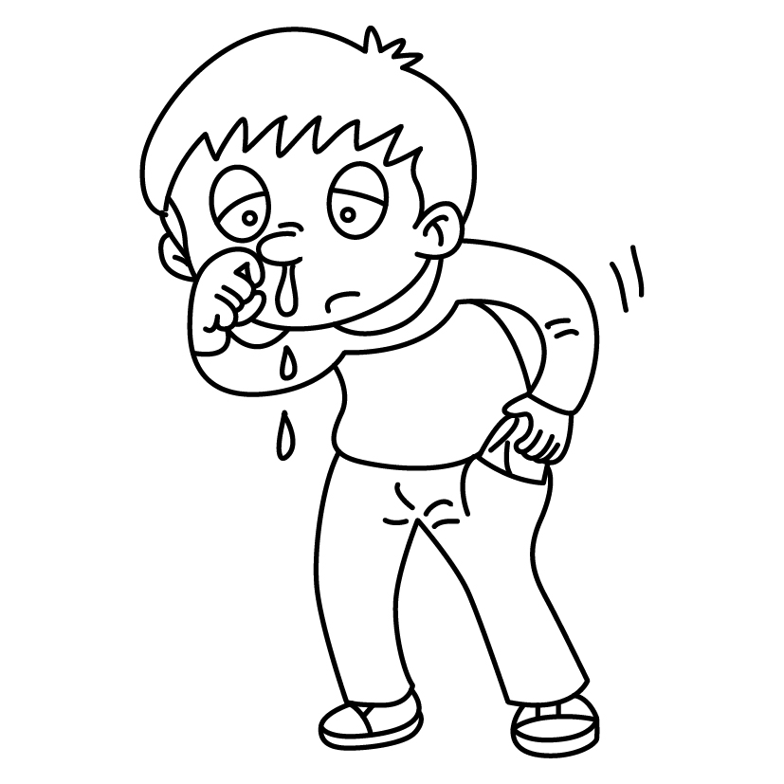

1. T: What do you see?

S: I ______________________.

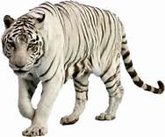

1. T:How many zebras are there?

S: _______________________________.

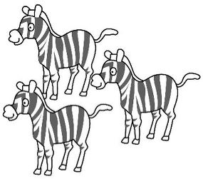

1. T: What’s wrong?

S: Her ____________________.

**C.韻文：老師抽一首**

1. Where’s my lunch?

It’s on the chair.

It’s on the chair in the church.

2. The boy is short. He has a shop.

He sells fish in the shop.

3.This is the king. He has a ring.

The king with a ring likes to sing.

4.This is Hank. He goes to the bank.

He goes to the bank in pink.

**D. 課文 (老師抽一課)**